Task 11
Practice task
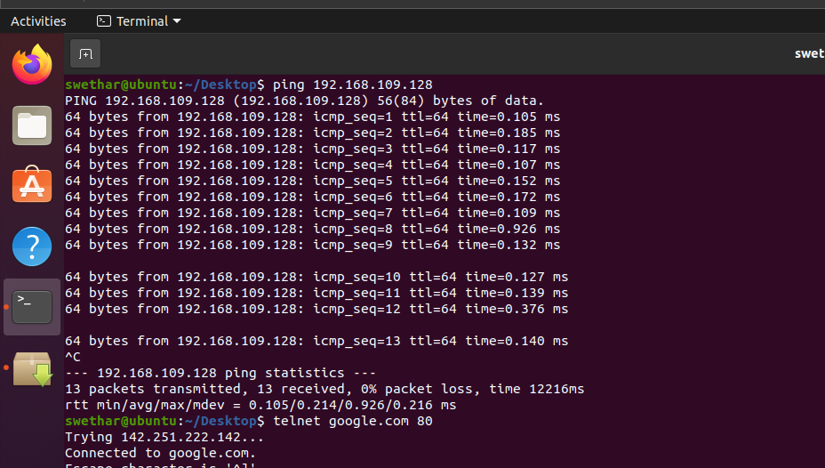
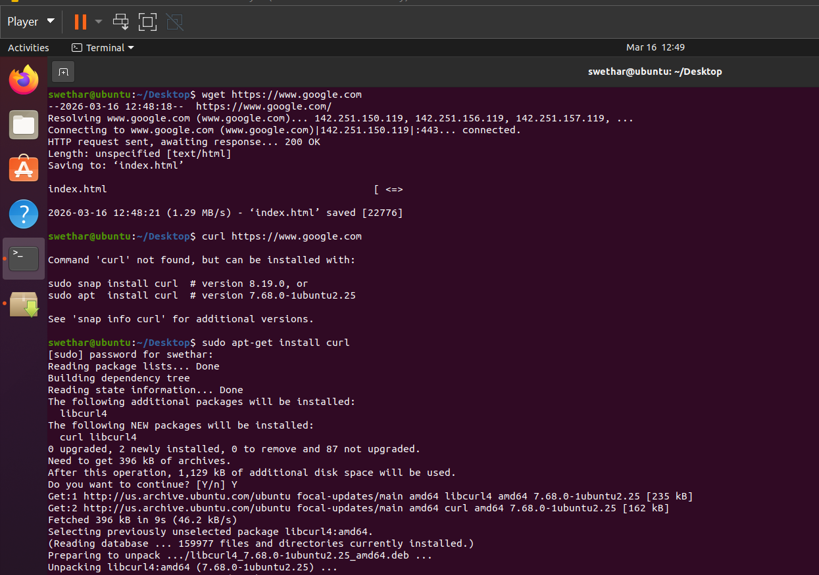

1.Difference between wget and curl command
wget | curl
Used mainly to download files from the internet | Used to transfer data from/to servers
Can download files directly | Can send requests (GET, POST, PUT)
Works mostly for downloading | Works with many protocols (HTTP, FTP, API requests)
Note: execute wget and curl with an example
